1a.
D₇ | D₆ | D₅ | D₄ | D₃ | D₂ | D₁ | D₀ | Q₂ | Q₁ | Q₀
0 | 0 | 0 | 0 | 0 | 0 | 0 | 1 | 0 | 0 | 0
0 | 0 | 0 | 0 | 0 | 0 | 1 | X | 0 | 0 | 1
0 | 0 | 0 | 0 | 0 | 1 | X | X | 0 | 1 | 0
0 | 0 | 0 | 0 | 1 | X | X | X | 0 | 1 | 1
0 | 0 | 0 | 1 | X | X | X | X | 1 | 0 | 0
0 | 0 | 1 | X | X | X | X | X | 1 | 0 | 1
0 | 1 | X | X | X | X | X | X | 1 | 1 | 0
1 | X | X | X | X | X | X | X | 1 | 1 | 1
1b. 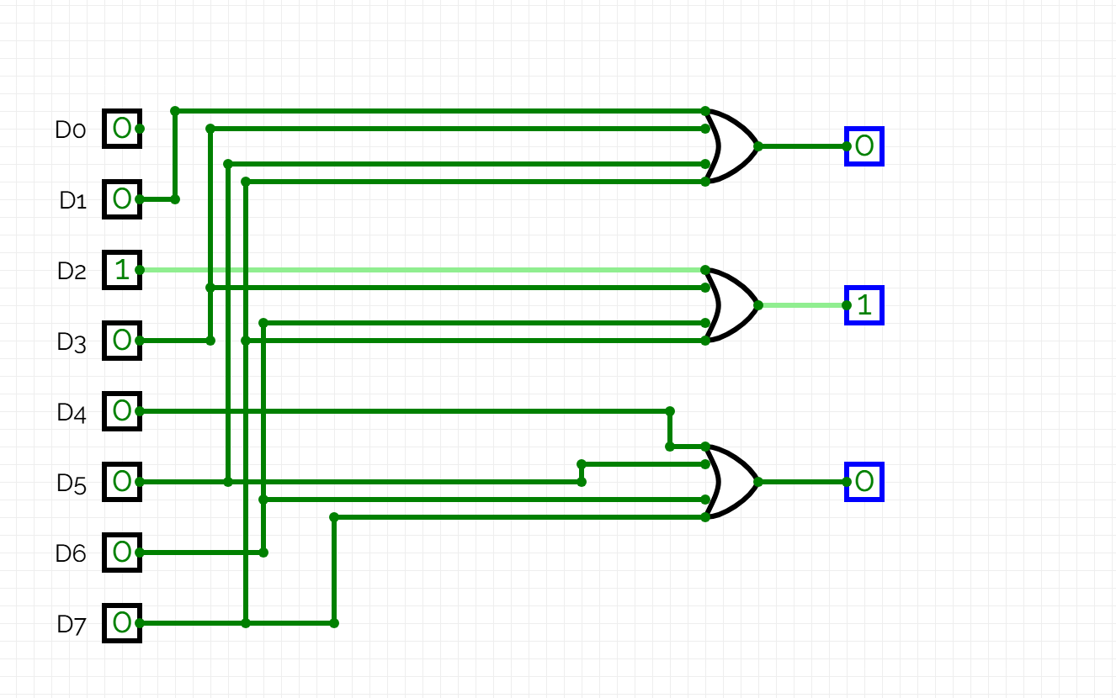
2a. Priority encoders can be used to reduce the number of wires needed in a particular circuits or application that have multiple inputs. Interface the keyboard to the PC using a priority encoder.

2b.
Compass Direction | Binary Outputs
North | 0 | 0 | 0
North-East | 0 | 0 | 1
East | 0 | 1 | 0
South-East | 0 | 1 | 1
South | 1 | 0 | 0
South-West | 1 | 0 | 1
West | 1 | 1 | 0
North-West | 1 | 1 | 1

2c.
